TRABALHO II - Individual

DATA DE ENTREGA

Projete um decodificador BCD para 7segmentos (Ativo baixo). O decodificador indica o grau final baseado na nota. Ou seja, notas entre:

* 9 Conceito A
* 8 Conceito B (b – minúsculo no display)
* 7 Conceito C
* 6 Exame (E)
* <=5 Conceito D (d – minúsculo no display)
* Códigos inválidos (I)

As entradas das notas devem ser feitas por chaves.

O trabalho (relatório) entregue deve conter :

1. o desenvolvimento do decodificador
2. Simplificação usando mapa de K
3. o projeto (usando o simulador)
4. a simulação
5. Introdução, conclusão, desenvolvimento.

Em relação ao simulador, pode ser:

a) Multisim - <http://www.ni.com/multisim/pt/>

b) MicroCap

c) ISE – Esta ferramenta o prof. João Fragoso deve usar com vocês nas disciplinas seguintes.

d) Outro.

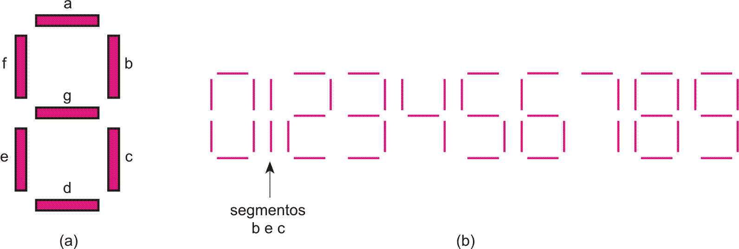

Solução

|  |  |  |  |  |  |  |  |  |  |  |
| --- | --- | --- | --- | --- | --- | --- | --- | --- | --- | --- |
| A | B | C | D | Ya | Yb | Yc | Yd | Ye | Yf | Yg |
| 0 | 0 | 0 | 0 | 1 | 0 | 0 | 0 | 0 | 1 | 0 |
| 0 | 0 | 0 | 1 | 1 | 0 | 0 | 0 | 0 | 1 | 0 |
| 0 | 0 | 1 | 0 | 1 | 0 | 0 | 0 | 0 | 1 | 0 |
| 0 | 0 | 1 | 1 | 1 | 0 | 0 | 0 | 0 | 1 | 0 |
| 0 | 1 | 0 | 0 | 1 | 0 | 0 | 0 | 0 | 1 | 0 |
| 0 | 1 | 0 | 1 | 1 | 0 | 0 | 0 | 0 | 1 | 0 |
| 0 | 1 | 1 | 0 | 0 | 1 | 1 | 0 | 0 | 0 | 0 |
| 0 | 1 | 1 | 1 | 0 | 1 | 1 | 0 | 0 | 0 | 1 |
| 1 | 0 | 0 | 0 | 1 | 1 | 0 | 0 | 0 | 0 | 0 |
| 1 | 0 | 0 | 1 | 0 | 0 | 0 | 1 | 0 | 0 | 0 |
| 1 | 0 | 1 | 0 | 1 | 0 | 0 | 1 | 1 | 1 | 1 |
| 1 | 0 | 1 | 1 | 1 | 0 | 0 | 1 | 1 | 1 | 1 |
| 1 | 1 | 0 | 0 | 1 | 0 | 0 | 1 | 1 | 1 | 1 |
| 1 | 1 | 0 | 1 | 1 | 0 | 0 | 1 | 1 | 1 | 1 |
| 1 | 1 | 1 | 0 | 1 | 0 | 0 | 1 | 1 | 1 | 1 |
| 1 | 1 | 1 | 1 | 1 | 0 | 0 | 1 | 1 | 1 | 1 |

|  |  |  |  |  |  |  |  |  |  |  |
| --- | --- | --- | --- | --- | --- | --- | --- | --- | --- | --- |
|  | CD |  |  |  |  |  | CD |  |  |  |
| *AB* | 00 | 01 | 11 | 10 |  | AB | 00 | 01 | 11 | 10 |
| 00 |  |  |  |  |  | 00 |  |  |  |  |
| 01 |  |  |  |  |  | 01 |  |  |  |  |
| 11 |  |  |  |  |  | 11 |  |  |  |  |
| 10 |  |  |  |  |  | 10 |  |  |  |  |

|  |  |  |  |  |  |  |  |  |  |  |
| --- | --- | --- | --- | --- | --- | --- | --- | --- | --- | --- |
|  | CD |  |  |  |  |  | CD |  |  |  |
| *AB* | 00 | 01 | 11 | 10 |  | AB | 00 | 01 | 11 | 10 |
| 00 |  |  |  |  |  | 00 |  |  |  |  |
| 01 |  |  |  |  |  | 01 |  |  |  |  |
| 11 |  |  |  |  |  | 11 |  |  |  |  |
| 10 |  |  |  |  |  | 10 |  |  |  |  |

|  |  |  |  |  |  |  |  |  |  |  |
| --- | --- | --- | --- | --- | --- | --- | --- | --- | --- | --- |
|  | CD |  |  |  |  |  | CD |  |  |  |
| *AB* | 00 | 01 | 11 | 10 |  | AB | 00 | 01 | 11 | 10 |
| 00 |  |  |  |  |  | 00 |  |  |  |  |
| 01 |  |  |  |  |  | 01 |  |  |  |  |
| 11 |  |  |  |  |  | 11 |  |  |  |  |
| 10 |  |  |  |  |  | 10 |  |  |  |  |

|  |  |  |  |  |  |  |  |  |  |  |
| --- | --- | --- | --- | --- | --- | --- | --- | --- | --- | --- |
|  | CD |  |  |  |  |  | CD |  |  |  |
| *AB* | 00 | 01 | 11 | 10 |  | AB | 00 | 01 | 11 | 10 |
| 00 |  |  |  |  |  | 00 |  |  |  |  |
| 01 |  |  |  |  |  | 01 |  |  |  |  |
| 11 |  |  |  |  |  | 11 |  |  |  |  |
| 10 |  |  |  |  |  | 10 |  |  |  |  |